Excerpts from
The Christmas Dream

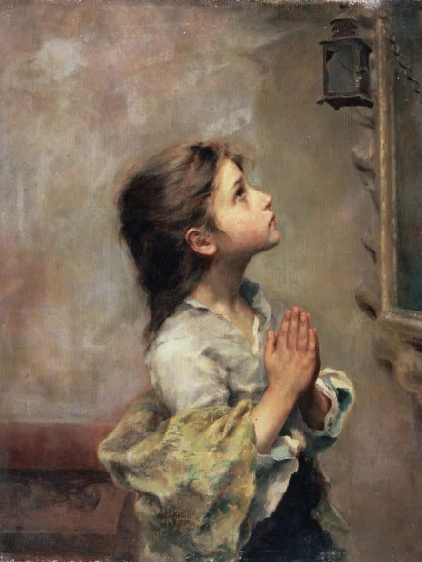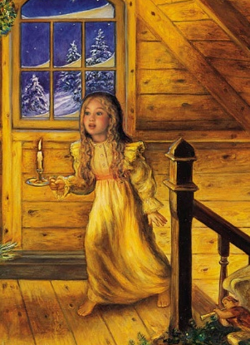

By Clare Diez
Creative Writing
Franklin Township Champions 4-H Club
Marion County
Advanced – Grade 11

Background:

The Christmas Dream provides the stories of five children from the small town of Pineroost during Christmastime in the early 1900s. The following excerpts come from the perspective of Christa Zimmerman, who lives with her German family on a small farm. Her oldest brother Hans has been away for many months, working a job in another town to help support the family.

Zimmerman Children’s Ages:
Hans: 19
Brigitta: 16
Christa: 10
Fritz: 8
Nick: 7
Louisa: 5

By Clare Diez

Excerpts from THE CHRISTMAS DREAM

The screen door opened three times. Twice it slammed as two boys clad in patched coats darted into the yard; once it creaked softly as a girl with coat sleeves ending before her wrists held it for a girl in a coat that reached her knees. The four met at the pile of stones in the yard’s center to debate over the day’s game.
“I say we play hide-and-seek,” Fritz said, stepping onto the highest rock.
“We could build things with the rocks at the back of the house,” said Christa, tugging on her wool mittens as she tried to cover her exposed wrists.
“We played that last week,” Fritz objected.
“We could just chase each other,” said Nick.
Louisa implored, “Can we play a sitting down game?”
“No, we’ll play hide and seek,” said Fritz. “I’ll be the seeker. And no hiding in the barn.”
“Why not?” Nick whined.
“Because that’s the first place you always hide. I’ll count now.” He pressed his face against the oak tree bark. “One, two…”
Christa and Nick sped off. Louisa stood still a moment, staring at Fritz’s back. Then she ran into the barn.
Christa had found the perfect spot – under the tarp folded in a heap in the wagon bed at the side of the house. She had just settled herself on the wooden boards, crumpling the tarp in its usual position, when it flew off of her.
“Hey!” Christa exclaimed.
“I couldn’t find anywhere to hide,” Nick said. “This will cover both of us.”
Christa opened her mouth, then shut it. She allowed him to cover them both with the tarp.
“We’ll never be found here,” he assured her. But he always said that.
A minute passed, then two. Christa could not hear Fritz walking around at all. Perhaps their spot was a good one.
“Found ya!” Fritz yanked the tarp off their backs. “You couldn’t fool me into thinking you weren’t under there!”
Christa stood up in the wagon and stretched. “Did you find Louisa yet?”
Fritz frowned. “No. I almost always find her first, her hiding spots are so silly.”
He searched the yard awhile longer, then had to admit he needed help. The three searched under all the bushes and behind all the trees. No Louisa.
“She’s gotta be hiding in the house or something. This isn’t fair!” Fritz wacked a tree trunk with a broken branch.
Christa looked up just in time to see a little head peep out of the barn door. “She’s in the barn!” Christa cried.
They raced to the barn. Louisa had pressed herself against the far wall, standing on top of the hay mound.
“What are you doing in here?” Fritz demanded. “You know the rules!”
Louisa stared at the three faces staring back at her. Her face crumpled into tears. “I don’t feel good!” she sobbed.
Fritz sighed impatiently, but Christa brushed passed him and stepped into the hay next to her sister. “Where don’t you feel good?”
“My tummy!”
Christa put her arm around her and led her out of the barn. “You come inside and lay in bed,” she said. “Mama will make you something nice to eat, and maybe later she’ll read you a story.”
Louisa’s sobs reduced to sniffles. It probably wasn’t anything too serious. Little children were always coming down with something, and a few days in bed with tender care usually left them good as new.
If only it could have been that way.

(A week later)
Christa, Fritz, and Nick were seated on the front step when the doctor came, a cheerful man with a brisk step and a black bag swinging from his hand. “Hello, children,” he said, tipping his hat. “Come now, it can’t be that bad!”
When the door shut behind him, Fritz pouted. “I wish we weren’t outcasts. If we have to be outside, then Brigitta should be out here too.”
“Brigitta’s doing the dishes,” said Christa.
“Humph!” said Fritz.
Presently, they heard voices on the other side of the door. The doctor’s voice was saying, “She’ll need medicine right away. If money’s a problem…”
“We can pay,” Papa said. Christa could imagine the straightening of his back and the broadening of his shoulders as he said that. The doctor stepped out, a concerned look on his face, and did not acknowledge the children at all as he passed.
Later, Papa came home with two dark bottles of medicine. Christa noticed that the pile of new shingles in the barn intended for fixing the roof were gone. Papa must have sold them.
When the doctor visited a second time, Papa sent all of them, even Brigitta, to the barn to spread out new bedding for the livestock. When they returned to the house, faces flushed from the cold, the doctor had gone, and Mama and Papa were whispering behind the closed pantry door in German. The children hung up their wraps in silence, not even bothering to figure out the little German they knew in their parents’ conversation.
Heavy gloom had settled in the kitchen when they sat down to eat their tasteless supper. Mama came down from the bedroom where she had been tending to Louisa. She sunk into a chair and placed her head in her hands as though she had a headache.
No one spoke for a long time. At last Mama looked up and her eyes met Papa’s.
“Should we send for him?” Papa’s voice sounded deeper than normal.
Mama just nodded.
They wrote a letter to Hans, asking him to come home. Papa mailed it that very night.
(Christmas Eve)
Christa scattered feed in a half circle around her feet. The chickens darted forward and gobbled it. Louisa had always liked doing that job.
Christa stepped into the kitchen, where Nick was eating a slice of bread. The front door opened; the doctor had arrived. Without sending the children outside, Papa followed the doctor upstairs.
Immediately, Brigitta, Christa, Fritz, and Nick pressed themselves against banisters, listening, but the bedroom door was closed. Only when it opened did they hear the doctor say, “All we can do now is pray.” Their mother began to weep.
“I don’t want to be the youngest,” Nick whimpered.
Brigitta squeezed his shoulders and herded them into the sitting room just as the doctor thumped slowly down the stairs. Christa sat huddled in the arm chair, tracing the pattern of the faded upholstery with her finger tip over and over.
The doctor stood in the doorway and looked at them all. “I’m very sorry,” he said gently. “We just have to place it in the hands of God now. My wife will bring over some food later.”
Brigitta nodded limply. The doctor’s hand hovered over Fritz’s shoulder for a moment, then he left.
Papa entered the room, ducking under the doorway. His voice was strained and unsteady. “She has only a few more days to live.” He stood there helplessly, silent tears sliding down his face.
Fritz suddenly bolted from the room. Nick tucked his head under his arms and cried. Brigitta turned herself toward the window, staring without seeing. Christa couldn’t bear to look at Papa’s face. She slipped out the back door and leaned against the house, staring at the deep blue sky and filling her lungs with the cold air over and over until the initial panic died down. A feeling of temporary calm replaced it.
Louisa is not going to die.
Was it denial? Was she being irrational?
She couldn’t tell. She only felt she knew, somehow, deep within, that Louisa was not meant to die.
********
Ladies trickled in all afternoon, bringing warm food, offers of prayers, and fervent hopes that the child’s life would be spared.
Christa crept out of the house and took her father’s saw from the barn, then crossed the wet, barren field to a place where the pine trees grew thickly. At last she spied a little one in the shadows of two large pines. After sawing its trunk, she carried it to the side of the house, unseen by anyone else.
At nightfall, when everyone else was either in the sick room with Louisa or had gone to bed, Christa brought the tree in the sitting room, standing it in a pot filled with rocks. She located the wooden box that held their few Christmas ornaments in the closet under the stairs. Lifting the lid, a wave of sadness confronted her.
An angel ornament lay on top, made from crude sticks tied together with thread. Louisa had made it the previous year. Christa snapped her eyes shut against the pain. She scooped up the decorations and hurried back to the tree.
No one came to tell her to go to bed. She decorated the tree and sunk down on the davenport, surveying her work. Her mind kept returning to one thought. Where was Hans? They had written him. Why hadn’t he come by now?
She stretched out on the davenport and pulled a pillow under her head, her mind tossing and turning. Gone was the inner conviction of Louisa’s survival. What if Louisa –? What if Hans didn’t –?
Christa bolted upward. There was one thing she could do.
She knelt by the window, feeling the cold that seeped through in spite of the rags stuffed at the bottom to block the draft. Christa focused her eyes on the few tiny stars almost lost at the top of the sky. “Please, please, dear God, let Louisa live,” her heart begged. “Please, Blessed Mother, you loved Baby Jesus so much. Please ask Jesus to let her live. Make Hans come home. Amen.”
Already, peace was restoring itself within her soul. Her earlier conviction came flooding back. Surely Louisa would be all right. Surely Hans would come home soon. Surely…
She was more tired than she realized. Sinking back onto the davenport, she laid her head on the pillow and slept.
********
Christa sat up. Everything was dark, and absolutely silent. Then a sound made her heart freeze in her throat.
“Noooo, no!” The heart wrenching cry came from upstairs. It was her mother’s.
Christa flew off the davenport and escaped out the back door into the night. The night was cold, but the cold could not touch her. She tore across the yard, flung open the barn door, and threw herself into the mound of hay, the sobs ripping out of her, her shoulder shaking.
“Christa?”
Her tear blinded eyes turned toward the door. Hans.
He ran toward her, lifting her to her feet. “Christa, I just got here. What’s happened? What’s wrong?”
She couldn’t speak. His arm supporting her, he lifted her trembling chin and stared into her brown eyes. “What happened?”
Christa swallowed and chocked out, “Louisa’s dead.”
“She – no, she? No!” He clasped Christa to him and began to cry. Christa buried her head in his coat. If only this was some horrible nightmare. But no, now she could never be happy ever again.
Brigitta flew into the barn shouting “Christa!! Christa!! ... Hans!” she gasped, flinging her arms across his shoulders. Startled, Christa let go of him, and Brigitta whirled him around in a circle. “It’s going to be all right! It’s going to be all right! Louisa’s going to get better! She got better!”
“You mean, Louisa’s going to live?” Christa sobbed. Tears poured afresh down her face.
“Yes, yes, yes!” Brigitta sang. “Come and see!”
Hans took off sprinting. Brigitta grasped Christa’s hand and tugged her along. They burst through the back door and rushed to the stairs, almost tripping in their haste and efforts to be quiet. Hans reached the bedroom first, slowing his steps. He placed his hand on his mother’s shoulder. “Mama, I’m home.”
Mama breathed a long sigh and folded him in her embrace. Louisa looked up from the pillow, smiled, and reached out her little hand. Hans clasped it. “I’m home, little sister.”
“Just five minutes ago we couldn’t tell if Louisa was breathing,” Brigitta whispered in Christa’s ear, “And Mama cried out real loud. Then Louisa just – changed. She opened her eyes and smiled at us, and started breathing normally again. I’ll never forget this moment as long as I live.”
Nick grabbed ahold of Christa’s arm, his face bathed in relief and sheer joy. Fritz’s face was transformed like a sunrise, as he smiled wide for the first time in days. All began to hug each other. Mama took Christa into her arms and whispered “I love you.” Christa couldn’t say anything just then. Only her heart could repeat this one prayer to God: Thank you! Thank you!! Thank you!!!
Her father wrapped his strong arms around her. She could feel the pulses of their hearts beating together.
Then she sat carefully, reverently, at the edge of Louisa’s bed.
Louisa’s eyes glittered with a bit of her old spirit. “Christa.”
Christa leaned over and kissed her on the forehead. “I love you, Louisa. Merry Christmas.”

